The Pell City Police Department is a full-service, proactive, community-based, problem-solving police department that subscribes to the highest levels of professionalism, integrity and service.

On average, the agency responds to over 30,000 calls-for-service annually and makes approximately 1,000 arrests. Officers are multi-tasked and cross-trained to perform numerous diversified specialties and are well respected among their peers for having the highest levels of performance and efficiency.

**Mission Statement**

*It is the mission of the Pell City Police Department to safeguard the lives and property of the people we serve, to reduce the incidence and fear of crime, and to enhance public safety while working with the diverse communities to improve their quality of life. Our mandate is to do so with honor and integrity, while at all times conducting ourselves with the highest ethical standards to maintain public confidence.*

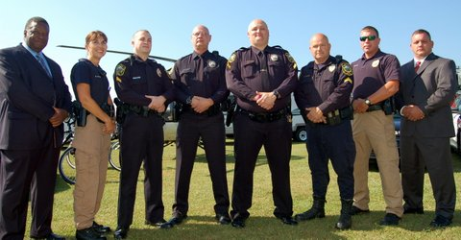

**Our Values as Pell City Officers**

***P****rofessionalism* ***C****ourage* ***P****ride* ***D****edication*



***OUR CODE***

**Law Enforcement Code of Ethics**

***As a Law Enforcement Officer****, my fundamental duty is to serve mankind; to safeguard lives and property; to protect the innocent against deception, the weak against oppression or intimidation, and the peaceful against violence or disorder; and to respect the Constitutional rights of all persons to liberty, equality and justice.*

***I will*** *keep my private life unsullied as an example to all; maintain courageous calm in the face of danger, scorn or ridicule; develop self-restraint; and be constantly mindful of the welfare of others. Honest in thought and deed in both my personal and official life, I will be exemplary in obeying the laws of the land and the regulations of my department. Whatever I see or hear of a confidential nature or that is confided to me in my official capacity will be kept ever secret unless revelation is necessary in the performance of my duty.*

***I will never*** *act officiously or permit personal feelings, prejudices, animosities or friendships to influence my decisions. With no compromise for crime and with relentless prosecution of criminal, I will enforce the law courteously and appropriately without fear or favor, malice or ill will, never employing unnecessary force or violence and never accepting gratuities.*

***I recognize*** *the badge of my office as a symbol of public faith, and I accept it as a public trust to be held so long as I am true to the ethics of the police service. I will constantly strive to achieve these objectives and ideals, dedicating myself before God to my chosen profession...law enforcement.*

***OUR HONOR***

*On my honor, I will never betray my badge, my integrity, my character, or the public trust. I will always have the courage to hold myself and others accountable for our actions. I will always uphold the constitution my community and the agency I serve.*

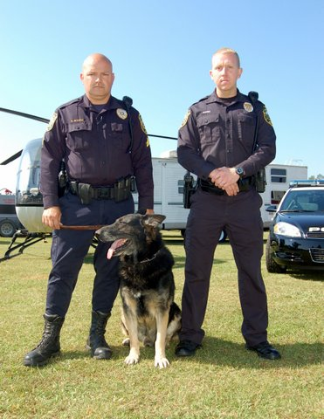

***OUR REALITY***

*“Policing is one of America's most noble professions. The actions of any police officer, in an instant can impact an individual for life and even a community for generations. Given this realization, every police officer must be centered on the fundamental principles of service, justice and fundamental fairness-The nobility of policing demands the noblest of character." Dr. Stephen R. Covey*

**

*Message from the Chief*

*To the Citizens of Pell City,*

*Our agency is proud to serve your family and our ever-growing business community. As it has shown over the last decade, the Pell City Police Department continues to be one of the leanest, professional, innovative, successful, and efficient agencies in our region.*

*Our success in 2012 is displayed in our numerous community programs that were over capacity, decreasing response times, acquiring over $5,000,000 in beneficial federal assets, acquiring the latest in crime fighting technology, exceptional crime reduction in a growing community, and operating a counter-drug program that is second-to-none. None of this would have been possible without one of the most important assets…the men and women that don the uniform and place the Pell City badge over their hearts every day in the selfless service to our community. Their character, courage, integrity and work ethic sets the example for other agencies to follow. I am extremely proud of them, our non-sworn staff and our volunteers that make this success possible. Lastly, our success is directly related to the support of our mayor, council, city manager and our community. The support and trust bestowed to us in 2012 was not taken for granted and led our agency into another premiere year of achievements and innovations.*

*In closing, our agency has adopted a new slogan as we move forward into 2013…”A Department of Excellence.” We recognize that excellence is not a destination, but a journey that brings out the best in everything that we do, how we do it and who we do it for…our community. As you review our annual report we hope that you continue to watch our agency as we transform from an outstanding agency to a department of excellence in 2013.*

*Respectfully Submitted,*

***Gregory Dean Turley***

*Chief of Police*