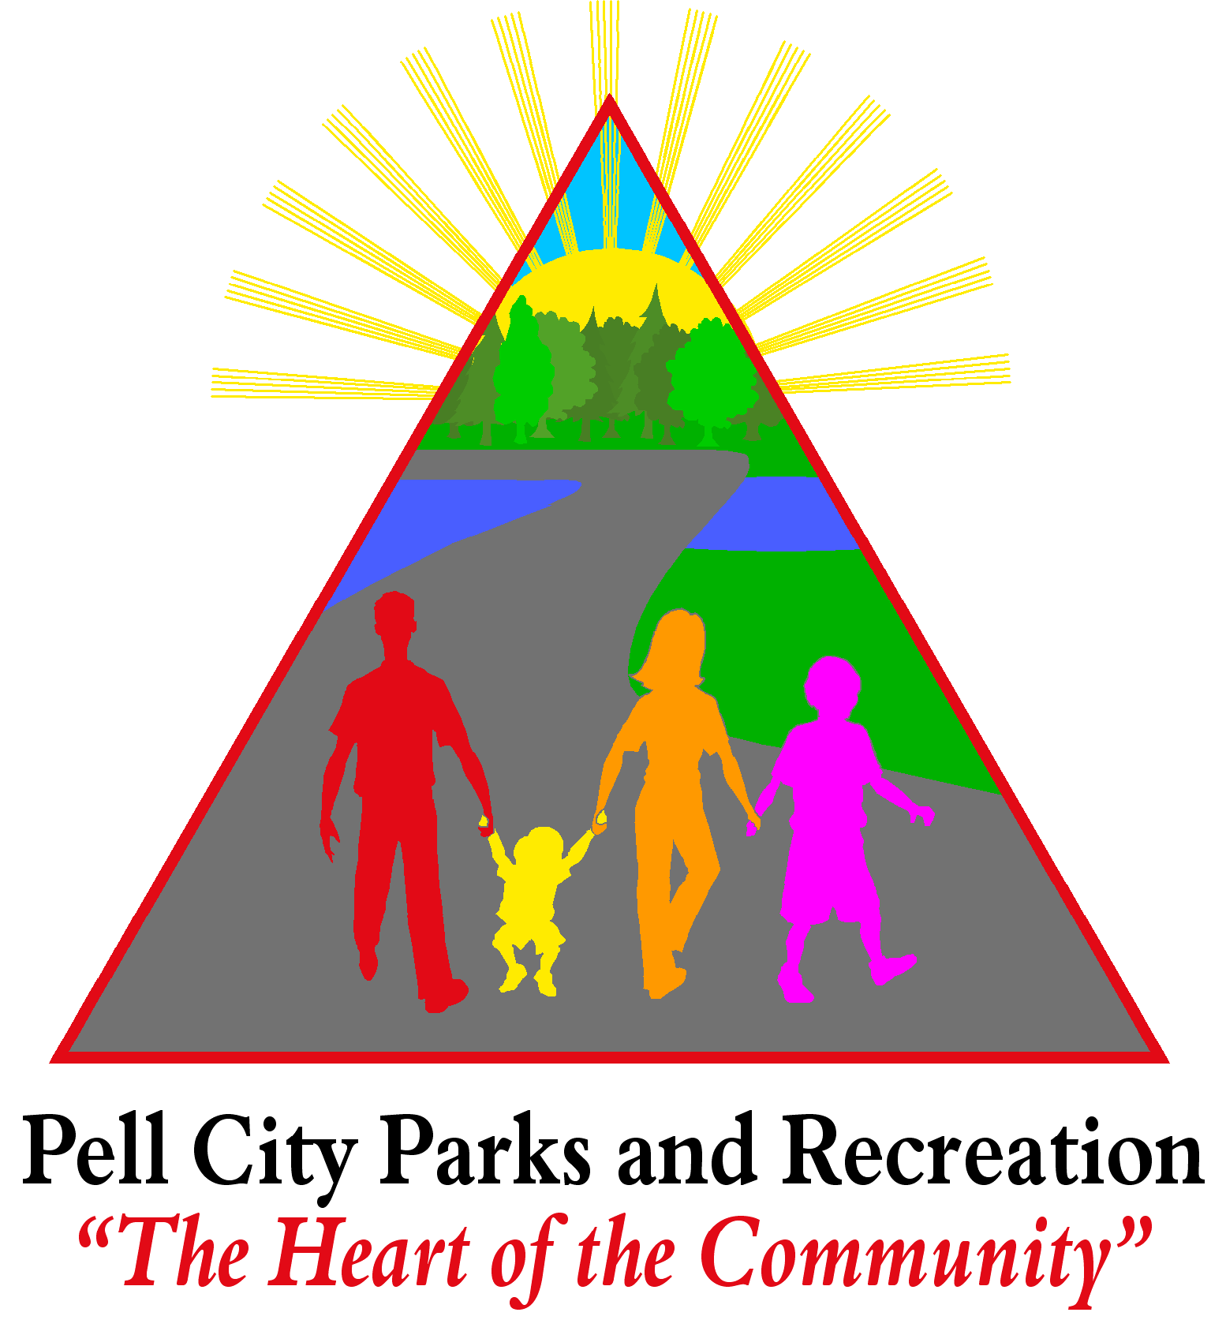
2016 Spring Sports Registration Form

Softball

Registration: January 4th – February 2nd | Evaluations  5 & 6 year olds Feb. 13th 10am  7 & 8 year olds Feb. 13th 11 am  9 & 10 year olds Feb. 13th 12pm  11 & 12 year olds Feb. 13th 1pm
Registration Fee: $100
(Fee includes Uniform & Trophy)

Player Information

Player’s Full Name & Nickname
Date of Birth & AGE
Street Address
City, Zip Code
Current Grade
Sibling in program?

Parent/Guardian Emergency Contact Information

Parent/Guardian #1 |  | Parent/Guardian #2
Relationship to Player |  | Relationship to Player
Work Phone |  | Work Phone
Cell Phone |  | Cell Phone
Email Address |  | Email Address

Volunteer Information
Help us make a better program for your child! Please indicate if you can donate time to help uniform distribution, coaching, assisting the coaches, team mom, and park clean up, or one of the many other positions needed to run a successful youth sports program.
Name
How do you want to get involved?

*If selected for all stars, additional fees may be required*

Page 2

Code of Conduct

I _____________________ understand that ANY person who engages in arguments, uses abusive language, harasses game or league officials, or exhibits any unsportsmanlike behavior may be removed from parks and/or recreation facilities.

Parental Consent

I, _______________________ am the legal parent or guardian of____________________. I hereby acknowledge that my child is in good general health. I give permission for my child to participate in any and all activities associated with the youth sports program specified by this registration form.

Emergency Medical Authorization

I hereby grant my permission for any and all emergency medical/dental treatment and/or first aid to be administered to my child/participant, including authorizing any medical treatment facility/hospital to administer emergency treatment, for any illness/injury/accident resulting from participation in any and all Pell City Youth Sports activity. Initial: ________

Medical Information

Please list any allergies/medical problems, including those requiring routine medications (i.e. diabetes, asthma, seizure disorder etc.)

Release of Liability

I/we the parent(s) and/or legal guardian(s) of the above named child know that participation in Pell City Youth Sports involves certain inherent risks. Participation in activities associated with Pell City Youth Sports programs may result in serious injury (ies), moreover protective equipment does not prevent the risk of injury (ies) to the participant. Therefore I assume all responsibility for said activity and/or child. I authorize the City of Pell City Parks and Recreation Department to obtain necessary medical care and treatment for the said participant for any illness or injury occurring during the activity period, but I understand that PCPARD is not assuming the duty to obtain medical treatment, make medical decisions, or render medical care or treatment to the participant. I release, indemnify and agree to hold harmless, PCPARD and its agents, elected officials, servants, and employees from all claims, actions, causes of actions, and rights of recovery, or reimbursements of any type that I may have and that any participant has or may have in the future which arise from or are related in any manner to the activity(ies)(including, but not limited to, claims of bodily injury and property damage or loss), and I assume all risks and hazards incident to such activities and transportation to and from the same. This instrument is signed both individually and on behalf of the participant(s) present at activity(ies).Initials____________

Parent/Guardian Signature____________________________________________Date________________

Parent/Guardian Signature____________________________________________Date________________

